

START

Smart Train Application for Route Testing

*For Version 1.0+*

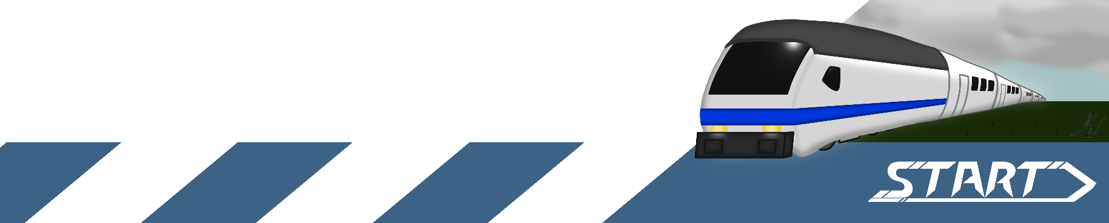

Manual author: [*M.Metsola*](https://github.com/RisenOutcast)

Contents

Functions 3

Track Editor 3

Train Editor 4

Simulation 5

Quick How-to-Guide 6

Info 6

Route basics 6

Simulation and playback 7

Settings 7

## Functions

Here is a basic rundown of all the features of the application.

Different views can be switched at the top left corner of the application.

### Track Editor

1. **Route dropdown**: Here you can switch between your routes.
2. **Route name**: Editable name for the route.
3. **Editing buttons**: For editing the route and its features.
4. **Stops**: Editable name fields for the stops. Selecting will highlight stop on map.
5. **Save all**: Saves all routes and trains.
6. **Export**: Export the current route as a file.
7. **Help**: Opens this guide.

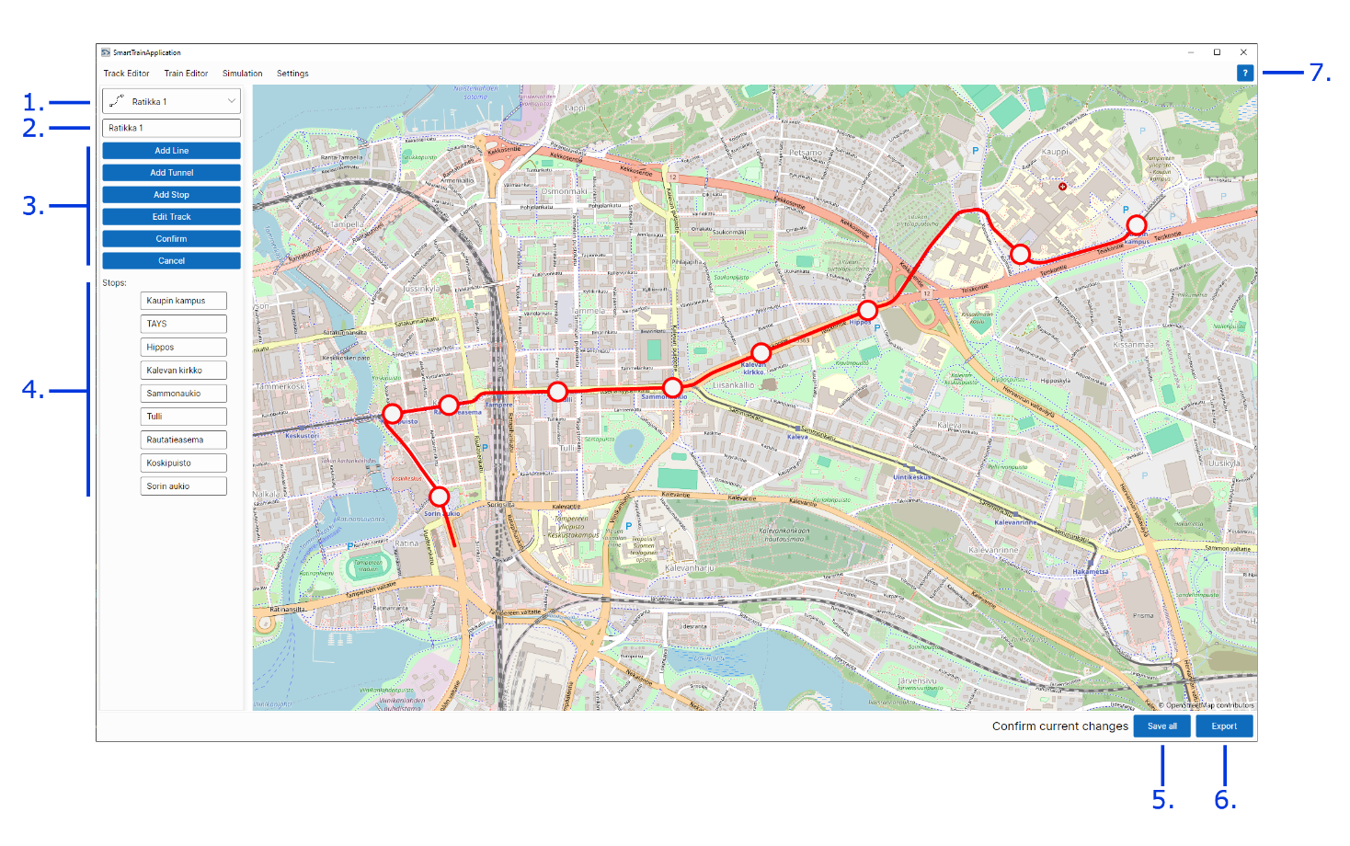

### Train Editor

1. **Train dropdown**: Here you can switch between your trains.
2. **Train name**: Editable name for the train.
3. **Description**: Optional description for the train.
4. **Maximum speed**: The maximum speed of the train.
5. **Acceleration**: Acceleration speed of the train
6. **Icon dropdown**: Icon for the train dropdown. 3 options.
7. **Update current**: Updates the values of the currently selected train.
8. **Create new**: Creates a new train with values.
9. **Save all**: Saves all routes and trains.
10. **Export**: Export the current route as a file.
11. **Help**: Opens this guide.

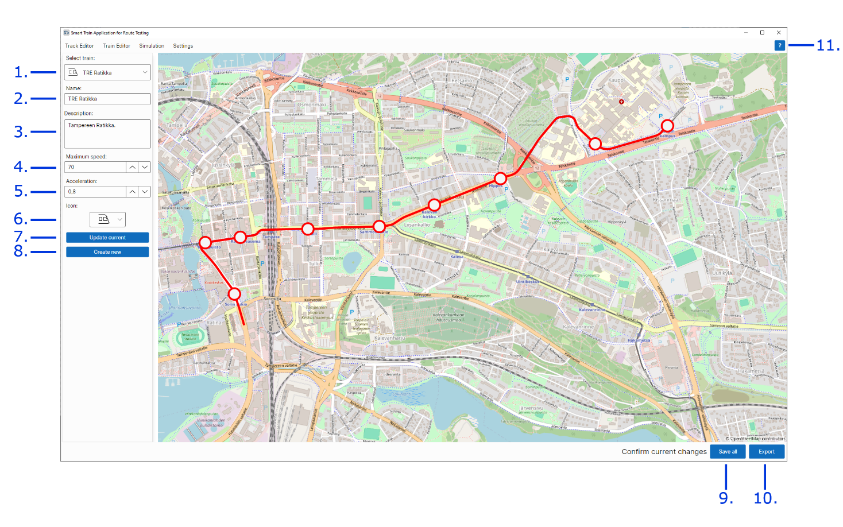

### Simulation

1. **Route dropdown**: Here you can switch between your routes.
2. **Train dropdown**: Here you can switch between your trains.
3. **Interval**: Speed of the simulation playback.
4. **Run simulation**: Start the simulation and playback.
5. **Stops**: Stops on the route. Hovering over will highlight stop on map. Selecting will make train wait on the stop.
6. **Save all**: Saves all routes and trains.
7. **Export**: Export the current simulation as a file.
8. **Help**: Opens this guide.

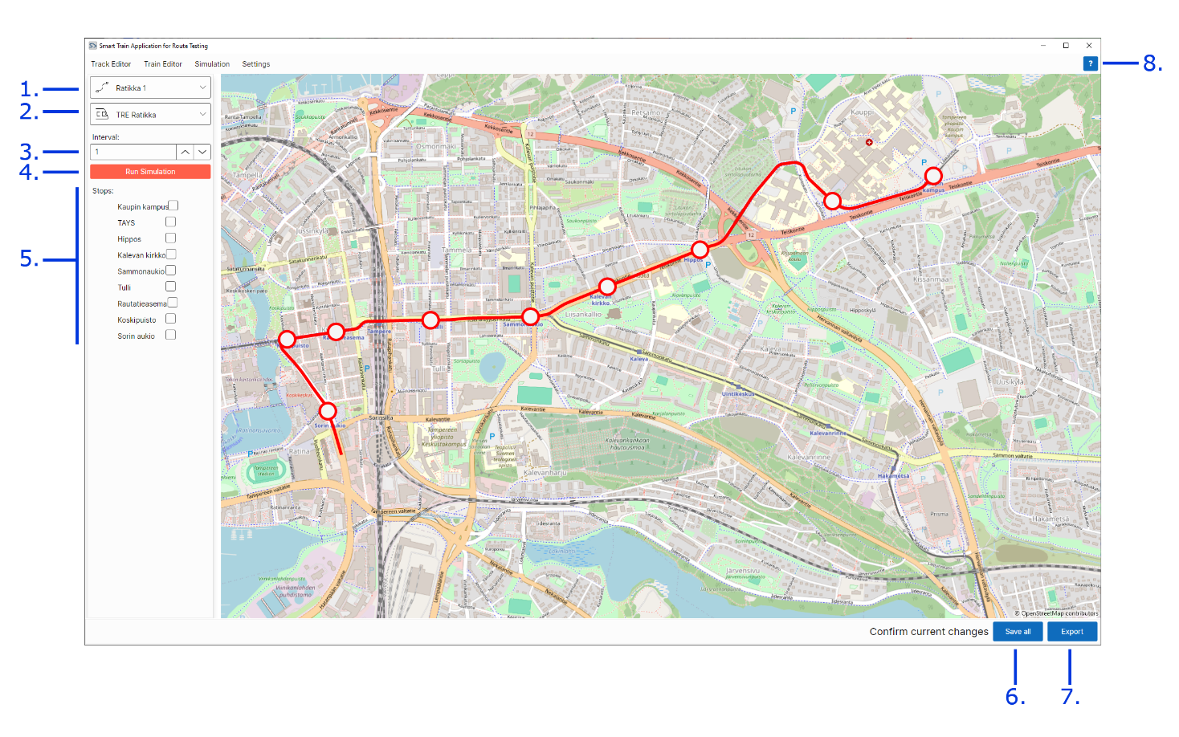

## Quick How-to-Guide

### Info

This tool can be used to create routes, trains and generate simulated data for the train moving through the route.

### Route basics

The routes are made of points, which are turned in to a line.

To create a new route, first click the **Add line** -button. The map turns editable, and you can start placing points on it. Note that the route points need to be added in order, from start to end.

Once you have added your points, hit the **Confirm** -button and you see your points turned to a line.

Now you can add tunnels and stops to your route. Both bind to the points you placed, so if you want precise placements for your tunnel entrances or stop, make sure you have points in those places. Hit the **Confirm** -button when you have placed the places for your tunnel entrances or stops.

**Note** that tunnels need two points! Entrances on both ends.

To later add additional points on the route or move the points hit to **Modify** -button to convert the line back to editable points. Points can be moved by click-hold and drag. Double-clicking line between points inserts new point there.

### Simulation and playback

Simulation can be run by first selecting the route and the train to be used in the simulation and then hitting the **Run simulation** -button. The application then generates the simulation file after which the playback starts to run in the map. The interval can be increased or decreased to make the playback faster or slower. It does not affect the generation of the simulation.

## Settings

In the settings you can change:

* The default location of the map to on startup.
* Add folders from where to import routes/trains on startup.
* Reset to default settings.

Note that all saved changes to settings come into effect after restarting the application.